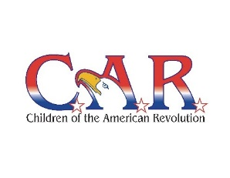

The Michigan Society of the
Children of the American Revolution
Joins a grateful Nation to honor
[NAME]
In recognition of
Patriotism Service Sacrifice
[Specify Service Details, e.g. “During the Vietnam War”]
Presented [DATE], [YEAR]

________________________________________ _____________________________________
President, [Your Society Name] Society Senior President, [Your Society Name]

